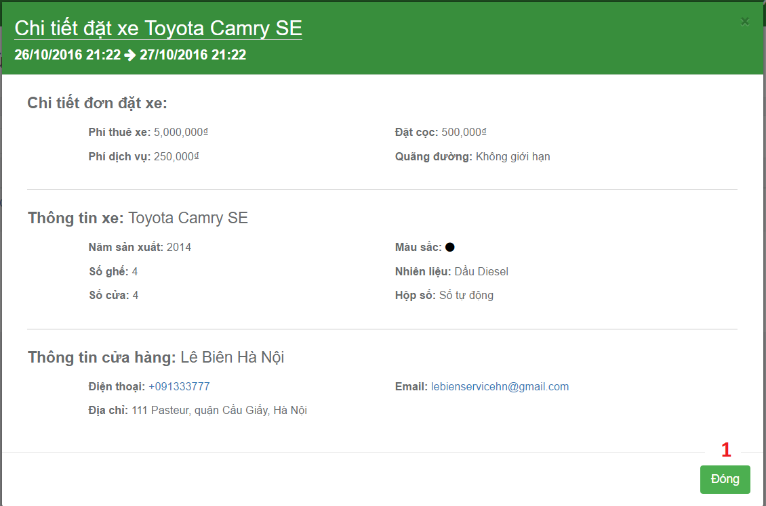

**Fields:** N/A.

**Buttons/Hyperlinks:**

|  |  |  |  |  |
| --- | --- | --- | --- | --- |
| No | Function | Description | Validation | Outcome |
| 1 | Close pop up | Close booking detail pop up | N/A | Close booking detail pop up. |